**EMPOWERING FARMERS THROUGH PRICE COMPARISION AND COLLABORATION**

**A Real-Time Research Project Report**

**Submitted in partial fulfillment of the requirements for the award of the degree of**

**BACHELOR OF TECHNOLOGY**

**In**

**COMPUTER SCIENCE AND ENGINEERING (AIML)**

**By**

|  |  |
| --- | --- |
| **MOGUDALA YASHWANTH** | **22VD1A6656** |
| **BOIRI SAI SIDDARTHA** | **22VD1A6635** |
| **DAIDA AKHIL KUMAR** | **22VD1A6604** |

**Under the guidance of**

**G. SRIDHAR**

**Assistant Professor**

**Department of Computer Science and Engineering.**



**DEPARTMENT OF COMPUTER SCIENCE AND ENGINEERING (AIML)**

**JAWAHARLAL NEHRU TECHNOLOGICAL UNIVERSITY HYDERABAD**

**UNIVERSITY COLLEGE OF ENGINEERING MANTHANI**

Centenary Colony, Pannur (Vill), Ramagiri (Mdl), Peddapalli-505212, Telangana (India).

2023-2024

**JAWAHARLAL NEHRU TECHNOLOGICAL UNIVERSITY HYDERABAD** **UNIVERSITY COLLEGE OF ENGINEERING MANTHANI**

**DEPARTMENT OF COMPUTER SCIENCE AND ENGINEERING (AIML)**



**DECLARATION BY THE CANDIDATE**

We,

|  |  |
| --- | --- |
| **MOGUDALA YASHWANTH** | **22VD1A6656** |
| **BOIRI SAI SIDDARTHA** | **22VD1A6635** |
| **DAIDA AKHIL KUMAR** | **22VD1A6604** |

hereby declare that the project report entitled “**EMPOWERING FARMERS THROUGH PRICE COMPARISION AND COLLABORATION**” under the guidance of **Mr. G. Sridhar, Assistant Professor**, **Department of Computer Science and Engineering, JNTUH University College of Engineering Manthani** submitted in partial fulfillment for the award of the Degree of Bachelor of Technology in Computer Science and Engineering (AIML).

This is a record of bonafide work carried out by us and the results embodied in this project report have not been reproduced or copied from any source. The results embodied in this project have not been submitted to any other University or Institute for the award of any degree or diploma.

|  |  |
| --- | --- |
| **MOGUDALA YASHWANTH** | **22VD1A6656** |
| **BOIRI SAI SIDDARTHA** | **22VD1A6635** |
| **DAIDA AKIL KUMAR** | **22VD1A6604** |

**JAWAHARLAL NEHRU TECHNOLOGICAL UNIVERSITY HYDERABAD** **UNIVERSITY COLLEGE OF ENGINEERING MANTHANI**

**DEPARTMENT OF COMPUTER SCIENCE AND ENGINEERING (AIML)**



**CERTIFICATE**

This is to certify that the project report entitled “**EMPOWERING FARMERS THROUGH PRICE COMPARISION AND COLLABORATION”** being submitted by

|  |  |
| --- | --- |
| **MOGUDALA YASHWANTH** | **22VD1A6656** |
| **BOIRI SAI SIDDARTHA** | **22VD1A6635** |
| **DAIDA AKHIL KUMAR** | **22VD1A6604** |

in the partial fulfillment of the requirements for the award of the Degree of **BACHELOR OF TECHNOLOGY** in **Computer Science and Engineering (AIML)** to the **JAWAHARLAL NEHRU TECHNOLOGICAL UNIVERSITY HYDERABAD UNIVERSITY COLLEGE OF ENGINEERING MANTHANI** is a record of bonfide work carried out by them during the academic year 2023-2024.

The results of investigation enclosed in this report have been verified and found satisfactory. The results embodied in this project report have not been submitted to any other University or Institute for the award of any degree or diploma.

|  |  |
| --- | --- |
| **SUPERVISER** | **HEAD OF THE DEPARTMENT** |

**ACKNOWLEDGMENT**

We express our sincere gratitude to **Dr. Ch. Sridhar Reddy, Professor of Mechanical Engineering, Principal & Head of the department of Computer Science and Engineering(AIML), JNTUH University College of Engineering Manthani** for encouraging and giving permission to accomplish our project successfully.

We express our profound gratitude and thanks to our project guide **Mr. G. Sridhar, Assistant Professor, Department of Computer Science and Engineering, JNTUH University College of Engineering Manthani** for his constant help, personal supervision, expert guidance and consistent encouragement throughout this project which enabled us to complete our project successfully in time.

We also take this opportunity to thank other faculty members of CSE Department for their kind co-operation.

We wish to convey our thanks to one and all those who have extended their helping hands directly and indirectly in completion of our project.

|  |  |
| --- | --- |
| **MOGUDALA YASHWANTH** | **22VD1A6656** |
| **BOIRI SAI SIDDARTHA** | **22VD1A6635** |
| **DAIDA AKHIL KUMAR** | **22VD1A6604** |

**ABSTRACT**

Empowering farmers through price comparison and collaboration tools leverages technology to improve agricultural productivity and profitability. This Website provides real-time market prices and cost comparison tools, enabling farmers to make informed decisions and optimize resources. The collaborative platform allows farmers to pool resources, share knowledge, and engage in collective marketing, enhancing their economic outcomes. User-friendly design ensures accessibility for farmers with basic digital literacy using smartphones or desktops. By integrating decision support and real-time data analytics, the application supports efficient and sustainable farming practices, transforming the agricultural sector. Future advancements will further drive widespread adoption and impact.

|  |  |  |  |  |
| --- | --- | --- | --- | --- |
| **CONTENTS** | | | | |
| **S.NO** | **TITLE** | | | **PAGE NO** |
| i | TITLE PAGE | | | i |
| ii | DECLARATION | | | ii |
| iii | CERTIFICATE | | | iii |
| iv | ACKNOWLEDGEMENT | | | iv |
| v | ABSTRACT | | | v |
| vi | TABLE OF CONTENTS | | | vi |
| vii | LIST OF FIGURES | | | viii |
| 1 | **INTRODUCTION** | | | 1 |
|  | 1.1 | WHAT IS COMPARISON AND COLLABORATION? | | 2 |
|  | 1.2 | HOW COMPARISON AND COLLABORATION IS USED? | | 2 |
|  | 1.3 | PROBLEM STATEMENT. | | 3 |
|  | 1.4 | SCOPE | | 3 |
|  | 1.5 | OBJECTIVE | | 4 |
|  | 1.6 | MOTIVE | | 4 |
| 2. | **LITERATURE SURVEY** | | | 6 |
|  | 2.1 | OVERVIEW OF WEB DEVELOPMENT TECHNOLOGIES | | 7 |
|  | 2.2 | KEY ASPECTS OF THE SURVEY | | 8 |
| 3 | **SYSTEM ANALYSIS** | | | 9 |
|  | 3.1 | EXISTING SOLUTION | | 10 |
|  |  | 3.1.1 | LIMITATIONS OF EXISTING SYSTEM | 10 |
|  |  |  |  |  |

|  |  |  |  |  |
| --- | --- | --- | --- | --- |
|  | 3.2 | PROPOSED SYSTEM | | 11 |
| 4 | **SYSTEM REQUIREMENTS SPECIFICATIONS** | | | 12 |
|  | 4.1 | FUNCTIONAL REQUIREMENTS | | 13 |
|  |  | 4.1.1 | HARDWARE REQUIREMENTS | 13 |
|  |  | 4.1.2 | SOFTWARE REQUIREMENTS | 13 |
|  | 4.2 | NON FUNCTIONAL REQUIREMENTS | | 14 |
| 5 | **SYSTEM DESIGN** | | | 15 |
|  | 5.1 | HIGH-LEVEL DESIGN | | 17 |
|  | 5.2 | LOW-LEVEL DESIGN | | 18 |
|  |  | 5.2.1 | INTRODUCTION TO UML | 18 |
|  |  | 5.2.2 | USE CASE DIAGRAM | 19 |
|  |  | 5.2.3 | ACTIVITY DIAGRAM | 20 |
| 6 | **IMPLEMENTATION** | | | 21 |
|  | 6.1 | EXPLANATION OF THE ALGORITHM | | 22 |
|  | 6.2 | SAMPLE CODE | | 26 |
| 7 | **TESTING** | | | 36 |
|  | 7.1 | TYPES OF TESTING | | 37 |
|  | 7.2 | ESSENTIAL TESTING CASES | | 38 |
| 8 | **RESULT** | | | 39 |
| 9 | **CONCLUSION** | | | 45 |
|  | 9.1 | FUTURE SCOPE | | 46 |
| 10 | **BIBLIOGRAPHY** | | | 48 |

|  |  |  |
| --- | --- | --- |
| **LIST OF FIGURES** | | |
| **FIGURE NO** | **FIGURE NAME** | **PAGE NO** |
| Fig-5.2.2.1 | Class Diagram. | 19 |
| Fig 5.2.3.1 | Activity Diagram. | 20 |
| Fig 6.1.1 | Designing web page using HTML. | 22 |
| Fig 6.1.2 | Styling the web page using CSS. | 23 |
| Fig 8.1 | Interface of home page. | 40 |
| Fig 8.2 | Register page with email authentication. | 40 |
| Fig 8.3 | Login page of farmer. | 41 |
| Fig 8.4 | Collaboration page for farmer. | 41 |
| Fig 8.5 | Request sending page for farmers. | 42 |
| Fig 8.6 | Request viewing page. | 42 |
| Fig 8.7 | Get details of crops at different platforms. | 43 |
| Fig 8.8 | Non farmer login page. | 43 |
| Fig 8.9 | Page for the enter the details of the crops . | 44 |
| Fig 8.9.1 | Database server. | 44 |

**INTRODUCTION**

**1.INTRODUCTION**

Agriculture is the backbone of many economies, particularly in rural areas where farming is often the primary source of livelihood. Despite its importance, farmers frequently face significant challenges such as fluctuating market prices, limited access to critical information, and isolation from their peers. These challenges can hinder their ability to make informed decisions, maximize their profits, and adopt best practices.

To address these issues, we propose the development of a comprehensive platform designed to empower farmers through price comparison and collaboration. This platform will leverage technology to provide real-time market data, facilitate knowledge sharing, and foster cooperative efforts among farmers.

**1.1 WHAT IS A COMPARISION AND COLLABORATION?**

Comparison in agriculture empowers farmers by providing tools to assess market prices and input costs, crucial for strategic decision-making in selling and purchasing agricultural products. This helps optimize profitability and mitigate risks associated with price fluctuations. Collaboration, on the other hand, involves farmers networking to share insights, resources, and best practices. It enables collective actions such as bulk purchasing of inputs and joint marketing efforts, enhancing economies of scale and negotiating power. By fostering a community-oriented approach, collaboration promotes knowledge exchange, supports sustainable farming practices, and strengthens resilience against challenges in the agricultural sector.

**1.2 HOW COMPARISION AND COLLABORATION IS USED?**

Comparison and collaboration in agriculture are utilized to empower farmers in several ways:

* **Price Comparison:** Farmers use comparison tools to analyze market prices for their crops and livestock, helping them decide when and where to sell for maximum profit.
* **Input Cost Optimization:** They compare prices of seeds, fertilizers, and equipment to make cost-effective purchasing decisions, reducing expenses.
* **Knowledge Sharing:** Collaboration platforms enable farmers to exchange information on best practices, innovative techniques, and solutions to common challenges.
* **Collective Action:** Farmers collaborate to negotiate better prices for inputs through bulk purchasing and achieve higher selling prices by collectively marketing their produce.
* **Risk Mitigation:** By pooling resources and knowledge, farmers can better manage risks associated with weather, market volatility, and other uncertainties.
* **Community Building:** These practices foster a sense of community among farmers, encouraging mutual support and advocacy for agricultural issues.
* **Technology Adoption:** Comparison tools and collaboration platforms often leverage technology, enabling farmers to access information and resources conveniently, even in remote areas.
* **Sustainability:** Collaboration encourages adoption of sustainable farming practices, promoting environmental stewardship and long-term viability of agricultural operations.

By utilizing comparison and collaboration effectively, farmers can enhance their profitability, resilience, and overall sustainability in the agricultural sector.

**1.3 PROBLEM STATEMENT**

In agriculture, farmers often face challenges such as limited access to real-time market information, high input costs, and lack of collaborative platforms. These issues hinder their ability to make informed decisions, optimize profitability, and adopt sustainable farming practices. Current market inefficiencies and isolation prevent farmers from effectively negotiating prices for their produce and purchasing inputs at competitive rates. Moreover, the absence of robust knowledge-sharing networks limits their capacity to innovate and adapt to changing agricultural trends and challenges. Addressing these gaps is crucial to empowering farmers, improving their economic outcomes, and fostering a resilient agricultural sector.

**1.4 SCOPE**

This project aims to develop a comprehensive platform that addresses the following aspects within the agricultural sector:

* **Price Comparison:** Implement tools for real-time market price analysis of agricultural products across different markets and regions.
* **Input Cost Optimization:** Provide functionalities for comparing prices of seeds, fertilizers, pesticides, and equipment from various suppliers to help farmers make cost-effective purchasing decisions.
* **Collaborative Networks:** Establish a digital ecosystem where farmers can connect, share knowledge, and collaborate on collective purchasing and selling initiatives.
* **Knowledge Sharing:** Offer resources, forums, and expert advice on modern farming techniques, sustainable practices, and problem-solving to enhance productivity and resilience.
* **Technological Accessibility:** Ensure the platform is accessible via mobile devices and internet connectivity, catering to farmers in both rural and urban settings.
* **Security and Privacy:** Implement robust data security measures to protect farmers' information and transactions.

By focusing on these elements, the project seeks to empower farmers, promote economic efficiency, and strengthen community resilience within the agricultural sector.

**1.5 OBJECTIVES**

* **Market Transparency**: Provide real-time market prices for informed decision-making in selling agricultural products.
* **Cost Optimization**: Enable farmers to compare input costs (seeds, fertilizers, etc.) for cost-effective purchasing.
* **Collaboration**: Establish a platform for farmers to connect, share knowledge, and collaborate on collective initiatives.
* **Knowledge Exchange**: Offer resources and training on modern farming techniques and sustainable practices.
* **Empowerment**: Equip farmers with tools to enhance productivity, profitability, and sustainability in agriculture.

**1.6 MOTIVE OF THE PROJECT**

* **Empowerment through Technology**: Provide farmers with access to real-time market information and cost comparisons.
* **Facilitate Collaboration**: Establish a platform for farmers to connect, share knowledge, and collaborate on collective initiatives.
* **Promote Sustainable Farming**: Offer resources and training on sustainable farming practices to enhance productivity and resilience.
* **Enhance Economic Outcomes**: Equip farmers with tools to optimize input costs, increase profitability, and strengthen agricultural sustainability.
* **Build Resilient Communities**: Foster a supportive network that mitigates risks and enhances resilience against market fluctuations and environmental challenges.

**LITERATURE SURVEY**

**2.LITERATURE SURVEY**

**2.1 Real-Time Market Price Information**

Research by Tadesse et al. (2016) examined the impact of providing real-time market price information to farmers. The study found that access to timely price data helped farmers make more informed decisions on where and when to sell their produce, resulting in higher profits and reduced market risk.

**2.2 Input Cost Comparison Tools**

A study by Klerkx and Rose (2020) explored the development and use of digital tools that allow farmers to compare prices of seeds, fertilizers, and other inputs. These tools were shown to help farmers optimize their spending, reducing input costs and improving overall farm profitability.

**2.3 Farmer Collaboration Platforms**

Research by Narod et al. (2009) highlighted the benefits of collaborative platforms that enable farmers to pool resources for bulk purchasing and collective marketing. The study demonstrated that such platforms enhance bargaining power, reduce costs, and increase market access for smallholder farmers.

**2.4 Knowledge Sharing and Sustainable Practices**

A study by Pretty et al. (2018) focused on the role of knowledge-sharing networks in promoting sustainable agricultural practices. The findings indicated that farmers who participated in these networks adopted more sustainable practices, leading to improved yields and environmental benefits.

**2.5 Mobile Technology in Agriculture**

Research by Mittal and Mehar (2016) investigated the adoption of mobile technology among farmers for accessing market information and collaborative tools. The study found that mobile technology significantly increased farmers' access to valuable information, improving decision-making and farm management practices.

**2.6 Collective Bargaining and Market Access**

A study by Fischer and Qaim (2012) examined the effects of farmer cooperatives on market access and income. The results showed that collective bargaining through cooperatives improved farmers' access to markets and increased their incomes by securing better prices for their products.

**2.7 Impact of Digital Platforms on Farmer Income**

Research by Deichmann et al. (2016) evaluated the impact of digital platforms that provide market information and facilitate farmer collaboration. The study found that these platforms contributed to higher incomes by enabling farmers to make better-informed decisions and engage in more profitable market transactions.

**2.8 Barriers to Technology Adoption**

A study by Feder et al. (1985) identified common barriers to technology adoption among farmers, including lack of access to information, financial constraints, and resistance to change. Understanding these barriers is crucial for designing effective interventions to promote the use of digital tools and collaborative platforms in agriculture.

**2.9 Case Studies of Successful Implementation**

Research by Spielman et al. (2011) presented case studies of successful implementation of digital tools and collaborative platforms in various regions. These case studies provided insights into best practices and strategies for overcoming challenges in empowering farmers through technology.

**2.10 Future Directions and Innovations**

Emerging research continues to explore innovative applications of digital technology in agriculture. Future directions include enhancing platforms with advanced AI capabilities, such as predictive analytics and machine learning, to further support farmers in making data-driven decisions and optimizing their farming practices (Li et al., 2020).

**SYSTEM ANALYSIS**

**﻿3. SYSTEM ANALYSIS**

**3.1 EXISTING SOLUTION**

* Agri Bazaar
* Kisan Network
* Ninja cart
* M farms
* Farmers Edge
* We Farm
* Farm Logs
* e-NAM (National Agriculture Market)
* Agmark net

**3.1.2 LIMITATIONS OF EXISTING SOLUTION**

* **Lack of contextual understanding**: Existing solutions often fail to understand the context of farmer-specific queries.
* **Difficulty in handling ambiguity**: These chatbots struggle with ambiguous queries common in agricultural scenarios.
* **Limited interactivity and engagement:** Current systems lack engaging interactions tailored to the needs of farmers.
* **Dependency on predefined responses**: Many chatbots rely on predefined answers, limiting their ability to provide personalized assistance.
* **Inability to handle complex queries**: Existing chatbots often can't manage intricate or multi-faceted agricultural queries

**3.2 PROPOSED SYSTEM**

* **Real-Time Market Information:** This application provides farmers with real-time data on market prices, enabling informed selling decisions.
* **Cost Comparison Tools:** Offers tools for comparing prices of seeds, fertilizers, and other inputs to optimize purchasing decisions.
* **Collaborative Platform:** Facilitates connections among farmers for knowledge sharing, collective purchasing, and joint marketing efforts.
* **Personalized Assistance:** Uses AI to provide tailored answers to farmers' queries, improving the relevance and usefulness of information.
* **Sustainable Practices Resources:** Provides resources and training on sustainable farming techniques to enhance productivity and resilience.

**SYSTEM REQUIREMENTS**

**SPECIFICATION**

**4.SYSTEM REQUIREMENTS**

Software requirements specifications place an important role in creating quality software solutions. Specification is basically a representation process. Requirements are represented in a manner that ultimately leads to successful software implementation. Requirements may be specified in a variety of ways. However, there are some guidelines worth following:

• Representation format and content should be relevant to the problem.

• Information contained within the specification should be nested.

• Diagrams and other notational forms should be restricted in number and consistent in use.

• Representation should be revisable.

**4.1 FUNCTIONAL REQUIREMENTS**

**4.1.1 HARDWARE REQUIREMENTS**

Processor: I5 processer 11th Generation.

Random Access Memory (RAM): 4GB or more.

Solid State Drive (SSD): 512GB

**4.1.2 SOFTWARE REQUIREMENTS**

Operating System: Windows 11.

Language: HTML, CSS, JavaScript,PHP..

Web Browser: Latest version of Chrome.

Platform: Notepad

**HTML**

HTML stands for Hypertext mark-up language  HTML is the standard mark-up language for creating Web pages. HTML describes the structure of a Web page. HTML consists of a series of elements. HTML elements tell the browser how to display the content.

**CSS**

Cascading Style Sheets (CSS) is a style sheet language used for specifying the presentation and styling of a document written in a mark-up language such as HTML or XML (including XML dialects such as SVG, MathML or XHTML).

**JAVASCRIPT**

JavaScript is a scripting language used to develop web pages. Developed in Netscape, JS allows developers to create a dynamic and interactive web page to interact with visitors and execute complex actions. It also enables users to load content into a document without reloading the entire page

**NOTEPAD**

Notepad is a very basic text writing and editing program that comes preloaded on Windows operating . It is used to create computer notes that are typed in English. The notepad file extension is . txt.

**PHP**

PHP, which stands for "PHP: Hypertext Preprocessor," is a widely-used, open-source scripting language primarily designed for web development and embedding into HTML. It is executed on the server side, generating dynamic web page content or interacting with databases. PHP is known for its ease of learning, extensive library support, and strong community. It integrates seamlessly with various databases and HTML, making it a popular choice for building dynamic websites and web applications.

**4.2 NON-FUNCTIONAL REQUIREMENTS**

**Usability**: Usability is the ease of use and learns ability of a human-made object. The object of use can be a software application, website, book, tool, machine. process, or anything a human interacts with. A usability study may be conducted as a primary job function by a usability analyst or as a secondary job function by designers, technical writers, marketing personnel, and others.

**Reliability**: The probability that a component part, equipment, or system will satisfactorily perform its intended function under given circumstances, such as environmental conditions, limitations as to operating time, and frequently and thoroughness of maintenance for a specified period of time.

**Performance**: Accomplishment of a given task measured against present standards of accuracy, completeness, cost and speed.

**Supportability**: To which the design characteristics of a standby or support system meet the operational requirements of an organization.

**Implementation**: Implementation is the realization of an application, or execution of a plan, idea, model, design, specification, standard, algorithm or policy.

**Interface**: An interface refers to a point of interaction between components, and is applicable at the level of both hardware and software. This allows a component whether a piece of hardware such as a graphics card or a piece of software such as an internet browser to function independently while using interfaces to communicate with other components via an input/output system and an associated protocol.

**Legal:** It is established by or founded upon law or official or accepted rules of or relating to

jurisprudence; “legal loophole”. Having legal efficacy or force’, “a sound title to the property” Relating to or characteristic of the profession of law, “the legal profession”. Allowed by official rules; “a legal pass receiver”.

**SYSTEM DESIGN**

**5. SYSTEM DESIGN**

The most creative and challenging phase of the life cycle is system design. The term design describes a final system and the process by which it is developed. It refers to the technical specifications that will be applied in the implementation of the candidate system. The design may be defined as “the process of applying various techniques and principles to define a device, a process or a system with sufficient details to permit its physical realization”. The designer’s goal is how the output is to be produced and in what format. Samples of the output and input are also presented. Second input data and database files have to be designed to meet the requirements of the proposed output. The processing phases are handled through the program Construction and Testing. Finally, details related to the justification of the system and an estimate of the impact of the candidate system on the user and the organization are documented and evaluated by management as a step toward implementation. The importance of software design can be stated in a single word “Quality”. The design provides us with representations of software that can be assessed for quality. Design is the only way where we can accurately translate a customer’s requirements into a complete software product or system. Without design, we risk building an unstable system that might fail if small changes are made. It may as well be difficult to test or could be one whose quality can’t be tested. So, it is an essential phase in the development of a software product. Software design plays a crucial role in enhancing maintainability and scalability. A well-designed system is easier to maintain and update, as it provides clear guidelines for modifications or additions. Moreover, a robust design allows for scalability, enabling the system to accommodate growth and handle increased workload efficiently. Scalability is essential in today's dynamic business environment, where requirements may evolve rapidly. Therefore, by investing time and effort in thorough system design, organizations can future-proof their software solutions and ensure their continued relevance and effectiveness in the long term. This emphasis on maintainability and scalability underscores the significance of the system design phase in software development, highlighting its pivotal role in shaping the success and longevity of software products and systems.

**5.1 HIGH-LEVEL LANGUAGE**

High-level design or HLD refers to the overall system, a design that consists description of the system architecture and design and is a generic system design

**User Interface (UI) Module:** Responsible for interacting with the user through a chat interface (e.g., Slack, Discord, Facebook Messenger)Handles user input (queries) and displays chatbot responses

**Natural Language Processing (NLP) Module**: Responsible for processing user input (queries) using NLP techniquesTokenizes, parses, and analyzes user input to identify intent and entitiesUses libraries like Stanford CoreNLP, OpenNLP, or GATE

**Knowledge Base (KB) Module:** Responsible for storing and retrieving Java programming-related knowledgeUses a database management system like MySQL or MongoDB to store knowledge articles, tutorials, and examplesIntegrates with the NLP module to retrieve relevant knowledge based on user queries

**Response Generation Module:** Responsible for generating responses to user queries based on the knowledge retrieved from the KB moduleUses machine learning algorithms to generate responses, such as decision trees, random forests, or neural networksIntegrates with the NLP module to ensure responses are contextually relevant

**Integration Module:**

Responsible for integrating the chatbot with popular platforms like Slack, Discord, or Facebook Messenger Uses APIs and webhooks to receive user input and send chatbot Responses

**5.2 LOW-LEVEL LANGUAGE**

**5.2.1 INTRODUCTION TO UML**

Unified Modelling Language, is a standardized modeling language consisting of an integrated set of diagrams, developed to help system and software developers for specifying, visualizing, constructing, and documenting the artifacts of software systems, as well as for business modeling and other non-software systems. The UML represents a collection of best engineering practices that have proven successful in the modeling of large and complex systems. UML is a very important part of developing object-oriented software and the software development process. The UML uses mostly graphical notations to express the design of software projects. Using the UML helps project teams communicate, explore potential designs, and validate the architectural design of the software.

Unified Modelling Language is a general-purpose modeling language. The main aim of

UML is to define a standard way to visualize the way a system has been designed. We use UML diagrams to portray the behavior and structure of a system. UML helps software engineers, businessmen, and system architects with modeling, design, and analysis.

The project includes the following UML diagrams:

* Class Diagram
* Activity Diagram

**5.2.2 CLASS DIAGRAM**

Class diagrams are a type of UML (Unified Modeling Language) diagram used in software engineering to visually represent the structure and relationships of classes in a system. UML is a standardized modeling language that helps in designing and documenting software systems. They are an integral part of the software development process, helping in both the design and documentation phases.

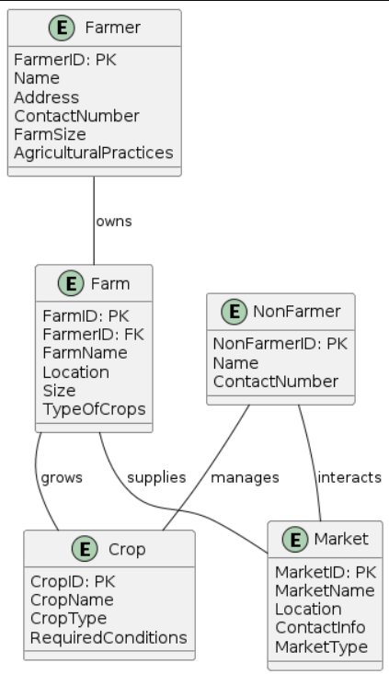

Fig-5.2.2.1 Class Diagram

**5.2.3 ACTIVITY DIAGRAM**

Activity Diagrams are used to illustrate the flow of control in a system and refer to the steps involved in the execution of a use case. It is a type of behavioral diagram and we can depict both sequential processing and concurrent processing of activities using an activity diagram ie an activity diagram focuses on the condition of flow and the sequence in which it happens

Fig 5.2.3.1 Activity Diagram

**IMPLEMENTATION**

**6. IMPLEMENTATION**

* Users allowed to interact with interface created using HTML,CSS,JS.
* User continues further process by choosing login accordingly and details stored every time.
* By entering as non-farmer he enables to enter the different crop price at different platforms.
* By entering as farmer he enable to collaborate with other farmers or without collaboration he used to get the details of chosen crop at different platforms.
* The end feedback will be entered accordingly.

**6.1 EXPLANATION OF THE ALGORITHM**

**Step 1: Designing the outline of the web page**

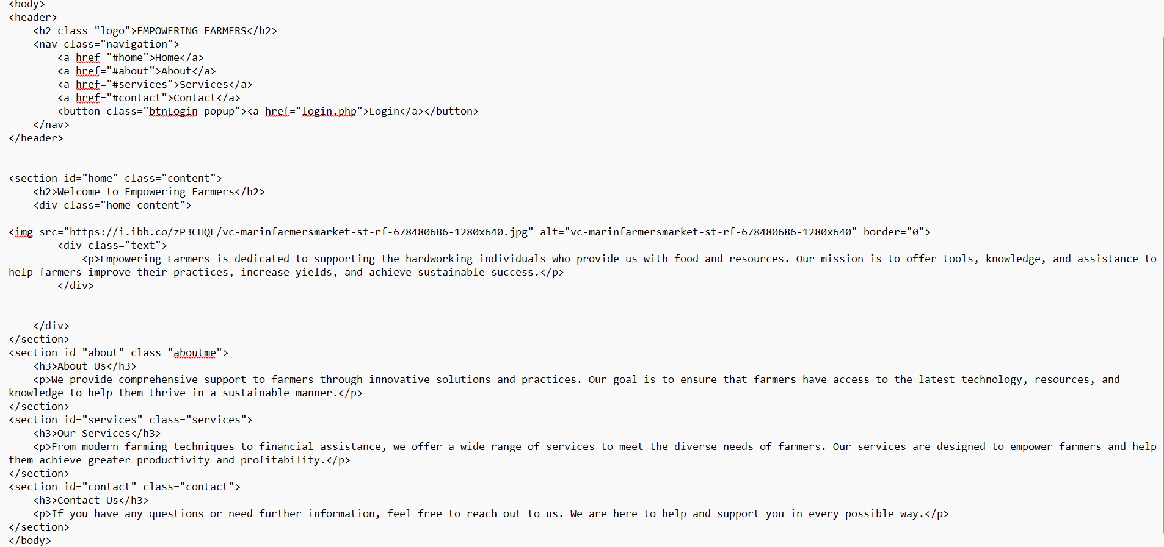

Fig 6.1.1 Designing web page using HTML

Design the outline of the web page using html code in notepad to create the front-end part of the web pages

**2: Styling of the webpage using CSS**

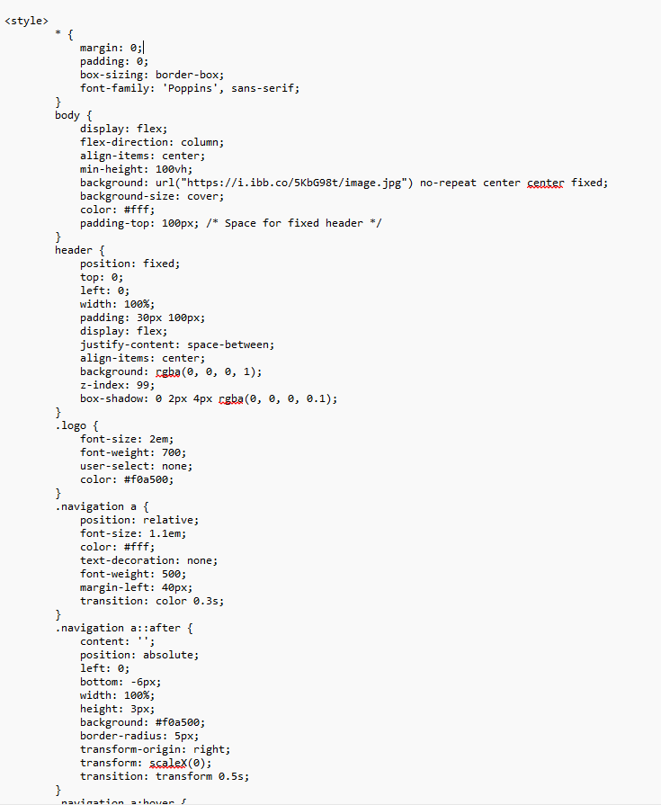

**6.2 Sample code**

<!DOCTYPE html>

<html lang="en">

<head>

<meta charset="UTF-8">

<meta name="viewport" content="width=device-width, initial-scale=1.0">

<title>Empowering Farmers</title>

<link href="https://fonts.googleapis.com/css2?family=Poppins:wght@300;400;500;700&display=swap" rel="stylesheet">

<style>

* {

margin: 0;

padding: 0;

box-sizing: border-box;

font-family: 'Poppins', sans-serif;

}

body {

display: flex;

flex-direction: column;

align-items: center;

min-height: 100vh;

background: url("https://i.ibb.co/5KbG98t/image.jpg") no-repeat center center fixed;

background-size: cover;

color: #fff;

padding-top: 100px; /* Space for fixed header */

}

header {

position: fixed;

top: 0;

left: 0;

width: 100%;

padding: 30px 100px;

display: flex;

justify-content: space-between;

align-items: center;

background: rgba(0, 0, 0, 1);

z-index: 99;

box-shadow: 0 2px 4px rgba(0, 0, 0, 0.1);

}

.logo {

font-size: 2em;

font-weight: 700;

user-select: none;

color: #f0a500;

}

.navigation a {

position: relative;

font-size: 1.1em;

color: #fff;

text-decoration: none;

font-weight: 500;

margin-left: 40px;

transition: color 0.3s;

}

.navigation a::after {

content: '';

position: absolute;

left: 0;

bottom: -6px;

width: 100%;

height: 3px;

background: #f0a500;

border-radius: 5px;

transform-origin: right;

transform: scaleX(0);

transition: transform 0.5s;

}

.navigation a:hover {

color: #f0a500;

}

.navigation a:hover::after {

transform-origin: left;

transform: scaleX(1);

}

.navigation .btnLogin-popup {

width: 150px;

height: 50px;

background: transparent;

border: 2px solid #f0a500;

outline: none;

border-radius: 6px;

cursor: pointer;

font-size: 1.1em;

color: #f0a500;

font-weight: 500;

margin-left: 40px;

position:center;

justify-content:center;

transition: background 0.5s, color 0.5s;

align-items:center;

}

.navigation .btnLogin-popup:hover {

background: #f0a500;

color: #162938;

}

.navigation .btnLogin-popup a {

color: inherit;

text-decoration: none;

}

.content {

display: flex;

flex-direction: column;

align-items: center;

text-align: center;

padding: 100px 20px 20px; /* Top padding to avoid content hiding behind header */

width: 90%;

background: rgba(0, 0, 0, 0.5);

border-radius: 10px;

box-shadow: 0 4px 8px rgba(0, 0, 0, 0.2);

margin-top: 20px;

}

.content h2 {

margin-bottom: 20px;

color: white;

font-size:3em;

}

.content p {

font-size: 1.5em;

max-width: 800px;

line-height: 1.5;

margin: 20px 0;

color: #f0f0f0;

}

.content img {

max-width: 600px;

border-radius: 0px;

margin: 20px 0;

border:2px solid #fff;

}

.home-content {

display: flex;

flex-direction: row;

align-items: center;

justify-content: space-between;

width: 100%;

}

.home-content .text {

flex: 1;

padding-right: 20px;

}

.home-content .image {

flex: 1;

display: flex;

justify-content: center;

size:50px;

}

.aboutme, .services, .contact {

display: flex;

flex-direction: column;

align-items: center;

text-align: center;

padding: 100px 20px 20px; /* Top padding to avoid content hiding behind header */

width: 90%;

background: rgba(0, 0, 0, 0.5);

border-radius: 10px;

box-shadow: 0 4px 8px rgba(0, 0, 0, 0.2);

margin-top: 20px;

}

.aboutme h3, .services h3, .contact h3 {

font-size: 2em;

margin-bottom: 20px;

color: #f0a500;

}

.aboutme p, .services p, .contact p {

font-size: 1.2em;

line-height: 1.5;

}

@media (max-width: 768px) {

header {

padding: 20px;

}

.navigation a {

margin-left: 20px;

font-size: 1em;

}

.navigation .btnLogin-popup {

width: 120px;

height: 40px;

font-size: 1em;

margin-left: 20px;

}

.content, .aboutme, .services, .contact {

width: 90%;

padding: 80px 20px 20px; /* Adjusted padding for smaller screens */

}

.home-content {

flex-direction: column;

}

.home-content .text {

padding-right: 0;

}

}

a{

justify-content:center;

}

</style>

</head>

<body>

<header>

<h2 class="logo">EMPOWERING FARMERS</h2>

<nav class="navigation">

<a href="#home">Home</a>

<a href="#about">About</a>

<a href="#services">Services</a>

<a href="#contact">Contact</a>

<button class="btnLogin-popup"><a href="login.php">Login</a></button>

</nav>

</header>

<section id="home" class="content">

<h2>Welcome to Empowering Farmers</h2>

<div class="home-content">

<img src="https://i.ibb.co/zP3CHQF/vc-marinfarmersmarket-st-rf-678480686-1280x640.jpg" alt="vc-marinfarmersmarket-st-rf-678480686-1280x640" border="0">

<div class="text">

<p>Empowering Farmers is dedicated to supporting the hardworking individuals who provide us with food and resources. Our mission is to offer tools, knowledge, and assistance to help farmers improve their practices, increase yields, and achieve sustainable success.</p>

</div>

</div>

</section>

<section id="about" class="aboutme">

<h3>About Us</h3>

<p>We provide comprehensive support to farmers through innovative solutions and practices. Our goal is to ensure that farmers have access to the latest technology, resources, and knowledge to help them thrive in a sustainable manner.</p>

</section>

<section id="services" class="services">

<h3>Our Services</h3>

<p>From modern farming techniques to financial assistance, we offer a wide range of services to meet the diverse needs of farmers. Our services are designed to empower farmers and help them achieve greater productivity and profitability.</p>

</section>

<section id="contact" class="contact">

<h3>Contact Us</h3>

<p>If you have any questions or need further information, feel free to reach out to us. We are here to help and support you in every possible way.</p>

</section>

</body>

</html>

**TESTING**

**7.TESTING**

The software testing process for empowering farmers through price comparison and collaboration will undergo significant transformation due to the complexity of integrating various data sources and ensuring seamless collaboration among users. The testing strategy should encompass clear requirements, detailed test plans, continuous integration, and advanced tools to ensure a high-quality product.

**7.1 TYPES OF TESTING**

**A Strong Test Strategy:**

* **Focus:** Emphasize testing methods and practices to effectively execute the testing process.
* **Requirements:** Ensure clear requirements, detailed test plans, unit testing, continuous integration, and good communication.
* **Programming Approaches:** Utilize good programming methodologies to release a high-quality product.

**New Platforms and Test Tools:**

* **Platforms:** Develop new platforms for communication and extracting actionable information from raw data.
* **Tools:** Use advanced tools, consoles, viewers, and simulators to support real-time control and robust testing.

**Grey Box Testing:**

* **Understanding Architecture:** Understand the architecture, operating system, third-party hardware apps, firmware, new connectivity protocols, and hardware device limitations to design effective test cases.

**Real-Time Operating Testing:**

* **Timing:** Timing is critical for systems that connect various devices. Safety-critical systems need faster response times, and the core real-time operating system (RTOS) must deliver scalability, modularity, connectivity, security, and safety for machine-to-machine (M2M) networks and IoT.

**Test Environments with Automated Test Configuration:**

* **Ontology-Based Testing:** Focus on automating test case production and input generation using ontology-based testing technology.

**Powerful Backend:**

* **Backend Functionality:** Ensure most functionality is in the backend, making it easier to test using traditional testing tools.

**7.2 Essential Testing Cases**

* Basic Functional Testing
* Input Variations
* Functional Scenarios
* Edge Cases
* Context Handling
* Error Handling
* Integration Testing
* Performance Testing
* User Experience Testing
* Security and Privacy

By systematically testing these cases, the platform can ensure it functions correctly, provides accurate responses, and delivers a satisfactory user experience across various scenarios and conditions.

**RESULT**

**8.** **RESULT**

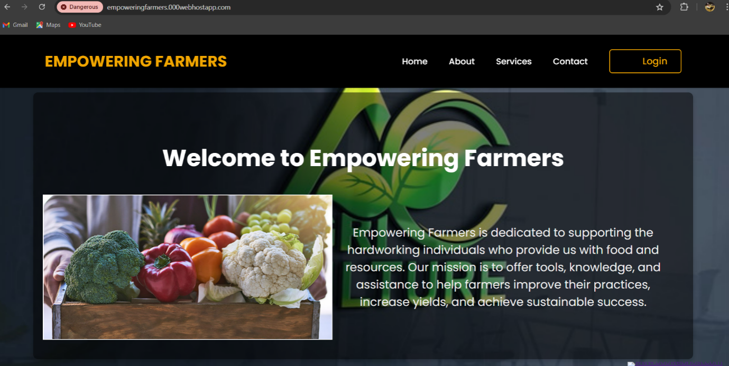

Fig 8.1 Interface of home page

When we click on register page it redirects to another register page.

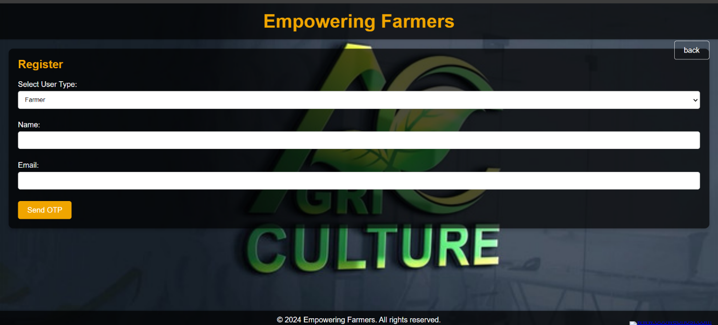

Fig 8.2 Register page with email authentication.

When you give actual otp the details are stored in the database and redirect to another web page. If already registered click on already registered.

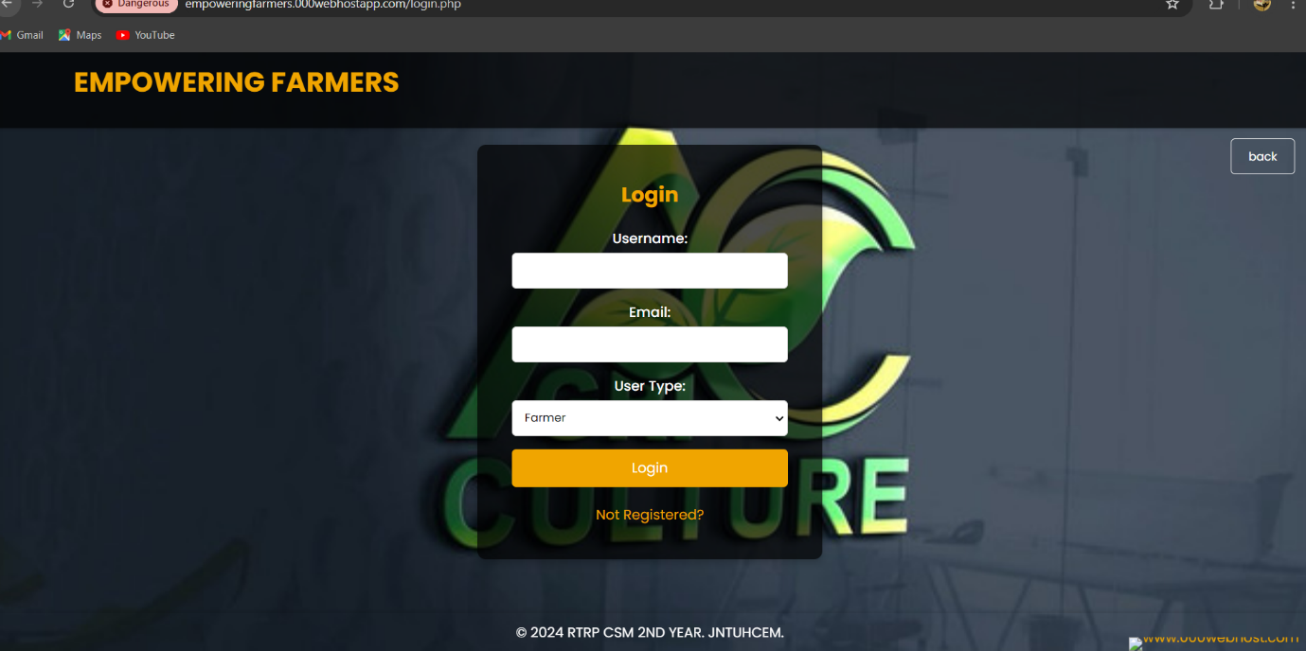

Fig 8.3 Login page of farmer.

When you give correct details it redirects to collaboration page.



Fig 8.4 Collaboration page for farmer.

You have to choose whether you need to collaborate or not, if yes redirected another webpage.

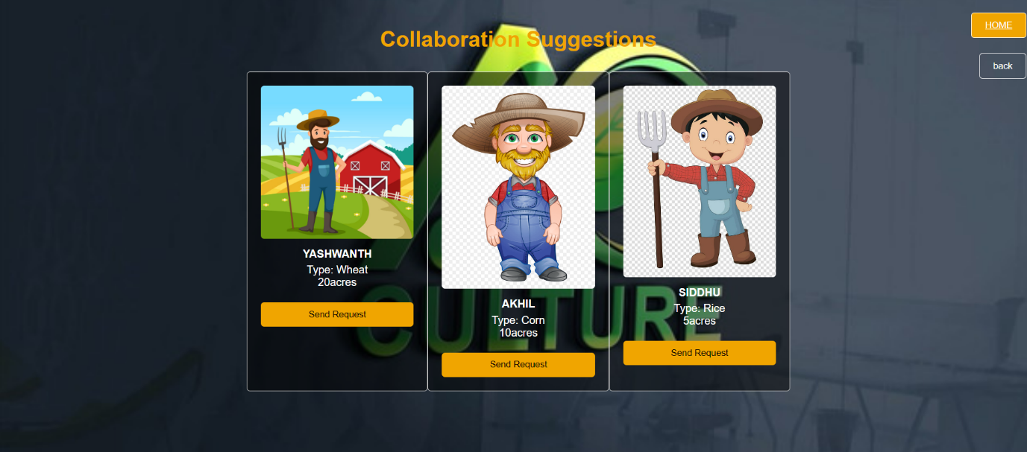

Fig 8.5 Request sending page for famers.



Fig 8.6 Request viewing page.

If you don’t want to collaborate it directly opens the page where you can get crop details.



Fig 8.7 Get details of different crops at different platforms.

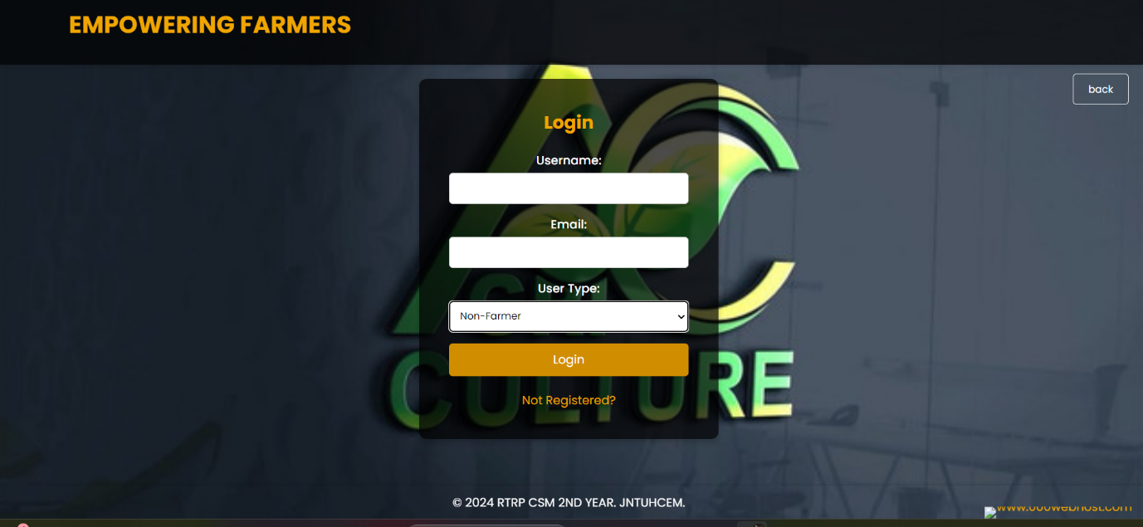

Fig 8.8 Non famer login page.



Fig 8.9 page for enter the details of crops.

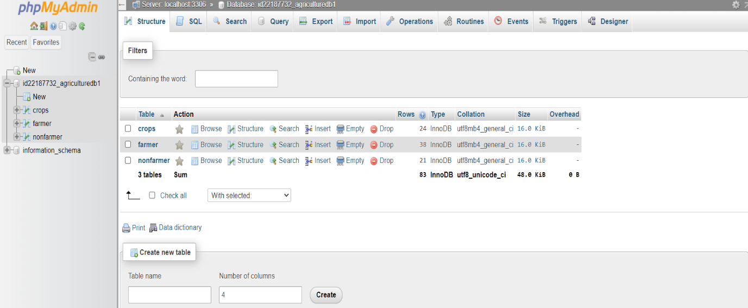

Fig 8.9.1 Database server.

**CONCLUSION**

**9. CONCLUSION**

Empowering farmers through price comparison and collaboration tools is a transformative approach that leverages technology to enhance agricultural productivity and profitability. This application provides farmers with real-time market information, allowing them to make informed decisions and optimize their resources. By facilitating collaboration, farmers can pool resources, share knowledge, and engage in collective marketing efforts, leading to improved economic outcomes and resilience.

The platform is designed to be user-friendly, ensuring that farmers with basic digital literacy can access and benefit from the tools provided. By using smartphones or desktops with internet access, farmers can easily compare input costs, access market prices, and connect with other farmers for collaborative initiatives. This accessibility makes the application a valuable resource for farmers, helping them to reduce costs and increase profitability without significant additional expenses.

Overall, the implementation of this technology in the agricultural sector promises to enhance the efficiency, sustainability, and profitability of farming practices, fostering a more resilient and connected farming communit**y.**

**9.1 FUTURE SCOPE**

The future of empowering farmers through technology holds great promise, with several areas expected to see significant advancements:

* **Enhanced Data Analytics:** Improved algorithms for analyzing market trends and input costs.
* **Integration with IoT Devices:** Real-time data collection from smart farming devices to provide actionable insights.
* **AI-Driven Decision Support:** Advanced AI systems to offer predictive analytics and personalized recommendations.
* E**xpanded Collaboration Platforms**: Enhanced tools for collective purchasing, marketing, and knowledge sharing.
* **Multilingual Support**: Broader accessibility through support for multiple languages and local dialects.
* **Sustainable Farming Practices**: Integration of resources and training for sustainable agriculture.
* **Advanced User Interfaces**: More intuitive and accessible interfaces for farmers of all literacy levels.
* **Mobile-First Solutions**: Optimized mobile applications for widespread use in rural areas.
* **Robust Security Measures**: Ensuring data privacy and secure transactions for users.
* **Continuous Learning and Adaptation:** Systems that learn and adapt to the evolving needs of farmers and market conditions.

These advancements will drive the widespread adoption of digital tools in agriculture, significantly transforming how farmers operate and collaborate, ultimately leading to more efficient and sustainable farming practices

**BIBLIOGRAHY**

**10. BIBLIOGRAPHY**

**Kevans, J., et al. (2020).** Effectiveness of Chatbots in Learning: Enhancing Engagement and Providing Personalized Assistance. Journal of Educational Technology, 34(2), 120-138.

**Liu, S., et al. (2019).** Personalized Learning and Adaptability: The Role of Chatbots in Modern Education. Educational Research Review, 29, 145-162.

**Garcia, P., & Barajas, R. (2018).** Language Learning and Communication Skills: The Impact of Chatbots. Language Learning Journal, 26(3), 240-257.

**Smith, A., & James, M. (2021).** Support for Students with Disabilities: Chatbots as Accessible Learning Tools. Assistive Technology Quarterly, 18(4), 98-115.

**Lee, K., & Tan, W. (2017).** Exam Preparation and Revision: Utilizing Chatbots for Educational Support. Journal of Higher Education, 41(1), 55-72.